**GIT KK**

1)mkdir : make directory

“it creates a folder”

2)cd project : cd means change directory

“it enters into the project folder.”

3)ls : ls means list of files/folders in the current directory

But in command prompt “ls” is not working. Alternative is “dir”

* use "cd .." To navigate to the previous directory (or back)

4)git init:

D:\GIT_KK>git init

Initialized empty Git repository in D:/GIT_KK/.git/

Initialises a empty git repository in current directory

5) type nul > names.txt : to create an empty file in that directory

6)git status:

Gives about the changes that happened recently ig

7) git add . : everything in that directory which is changed but not saved will be saved to the git repo

8)git commit -m “names file added” :

Giving a messege regarding the change we made

/* dir /ah shows hidden files Ig */

9)to edit a file:

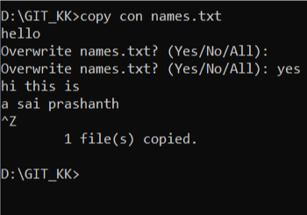

10)To display content in that text file:

Command: type names.txt

11) suppose if we saved the changes of our file by the command “git add . “ we can undo it by doing “git restore --staged names.txt”

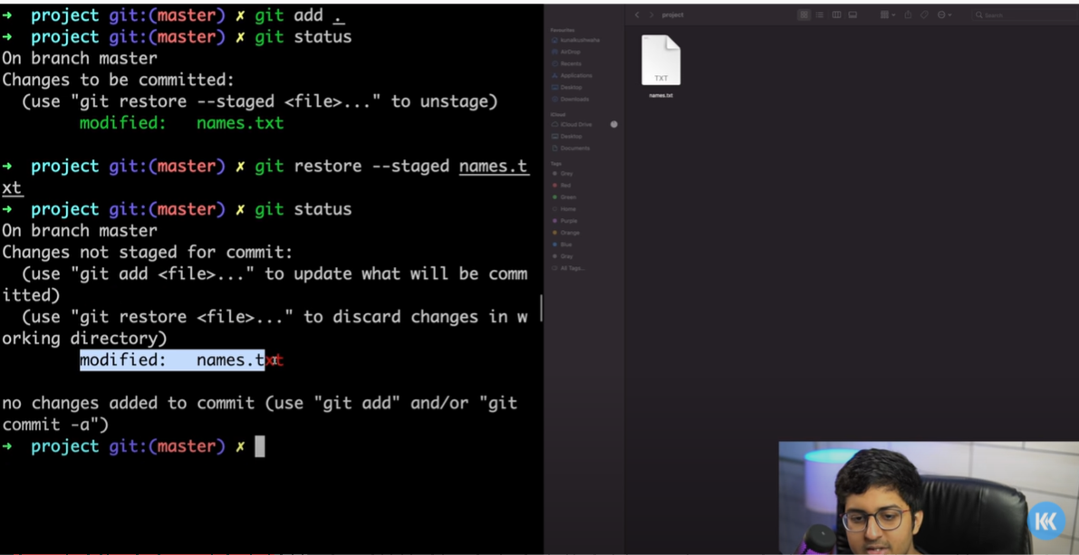

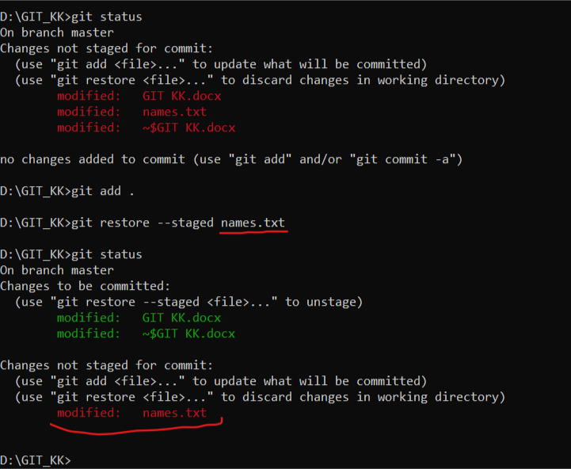

Here u typed to restore only names.txt so only that file changes have been not saved.

12)To see our entire commit history:

Use this command: “git log”

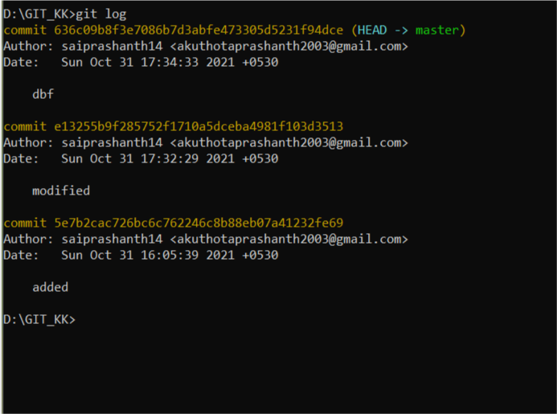

Commit id

14) suppose u want delete a commit or u want your changes to be undo so for that what we can do is. We can copy the commit id as shown in above picture. And then use this command “git reset <commit id>” . this command deletes all the commits above it

EX: as per above image if u want to go back to your repo that is there on sun oct 31 16:05:39 just copy that commit id and do

“git reset 5e7b2cac…………………..fe69” then all the commits that are above it will be deleted.

To exit git log, **type “q” or “z”**.

Git stash:

I didn’t understood this well please check the video again

The thing I understood is

Step-1: modify the file

Step-2: git add .

Step-3: instead of commiting we do “git stash” now these things are in back stage.

Step-4: if we want then back we do “git stash pop”

Step-5: if we want go clear the things which are in back stage we do “git stash clear” .

Adding our files to main repo in github.com:

step-1: create a repo in your github and copy the url and type

“git remote add origin <url>” ,“git push orgin master”

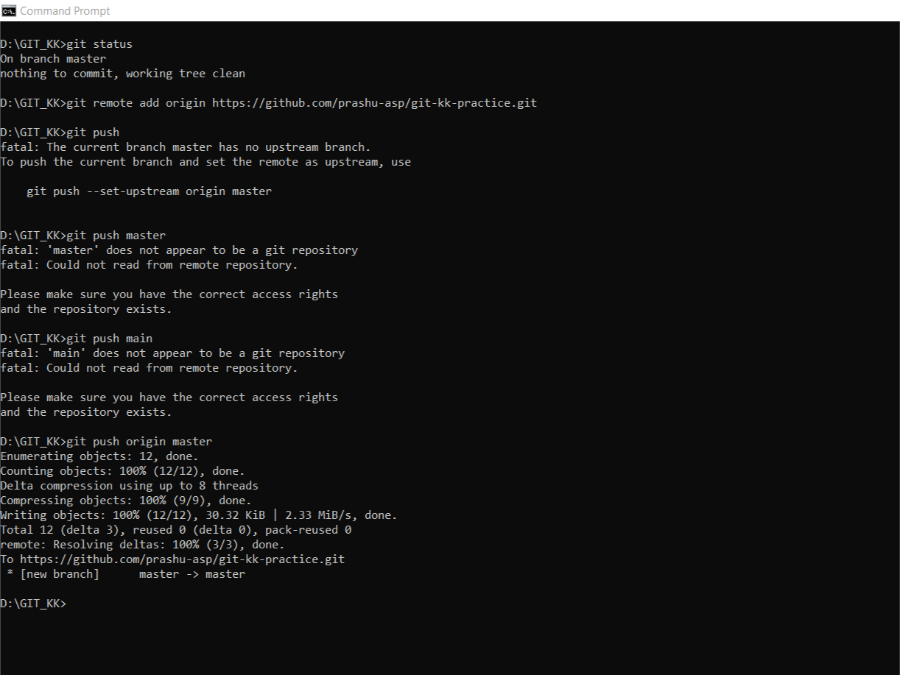Your commited changes will be updated to your github repo.

Then your repo in github will be updated. So yes this how u can update files to your github repo from local folder.

Now we will see how u can clone a repo to your local folder in your pc

Step-1: Fork a repo to your github account

Step-2: copy the url

Step-3: in cmd go to the folder (cd) where u want that repo files and type “git clone <url>”

Then all the files are downloaded to your folder now modify anything if u want.

And follow the procedure to update them in github repo.

1) git add .

2) git commit -m “jsbhf”

3) git push origin master(or main)

******FOR OPENSOURCE CONTRIBUTION OR ANY OTHER CONTRIBUTION Make pull request from the branch of your repo but not from main branch of the repo.  
why because basically each branch supports only one PR. So if u make a another PR from the same branch then it will be sent as a just commit to the previous PR.   
so if u want to add 10 new features to the main repo then if u add 1 feature and make a PR and then if u add another feature to the same branch and if u make a PR then this will be just sent as a commit to the previous PR. So the owners cant view your changes properly.  
so for every new PR should do it from a new branch.  
It will not even update your PR it will be in same place with two 2 commits. And if u modify the code belonging to previous PR then that also will changed here . So u should modify the code by making new branch and then make PR.

To create a new branch:

1) “git branch <branch name>”

2)”git checkout <branch name> “ (this makes that head is now in this branch.

Modify the files and then

3)git add .

4)git commit -m “jbhs”

5)git push origin <branch name> (origin means our local repo on our github.com page) (upstream means main repo of owners.)

Removing a commit from the pull request by force pushing to it:

1) git log

2) select the commit id which is just below the commit u want to delete

3)git reset <commit id>

4)git stash

5)git push origin <branch name> -f (here u need to force push this one as u want to delete the commit that is there in github.com website. That’s why “-f”)

****************

Suppose in your git repo  
u did one commit through cmd and another commit through github

Then git log in your cmd only shows one commit that is made through cmd  
if u want the commit that is made through github also   
then do  
  
“git pull”

This fetches the changes that made to your repo though github

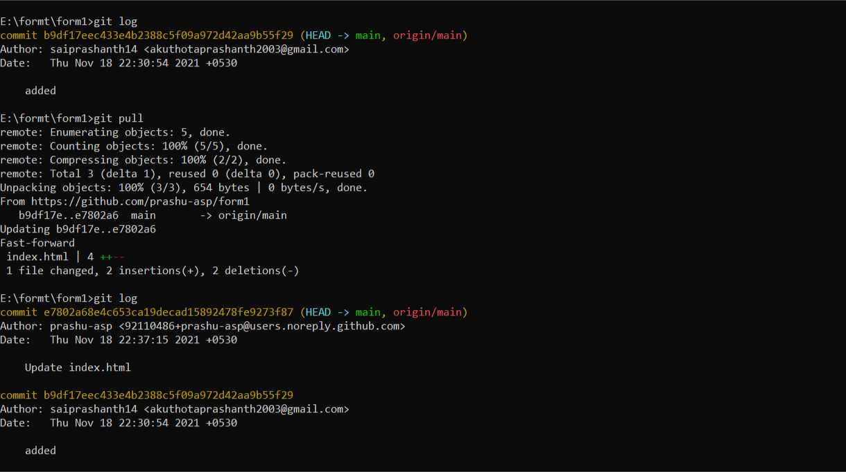Now if u click “git log” then u will see the all commits (through cmd made and through github made)